|  |  |
| --- | --- |
| **Ex No:01** | **Learn to use commands like tcpdump, netstat, ifconfig, nslookup and**  **traceroute. Capture ping and traceroute PDUs using a network protocol**  **analyzer and examine.** |
| **Date:** |

**AIM:**

To Learn to use commands like tcpdump, netstat, ifconfig, nslookup and traceroute ping

**Commands:-**

**netstat:-**

This command displays active TCP connections by default.

Example:-  
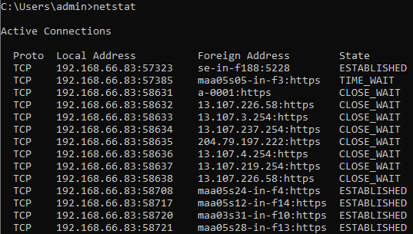

**Netstat commands with their flags:-**

**netstat -a:**

Shows all active connections and listening ports, both TCP and UDP.

Example

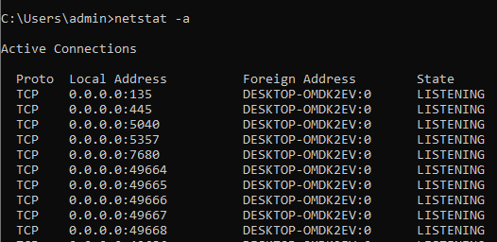

netstat -p tcp:

 Displays only TCP connections.

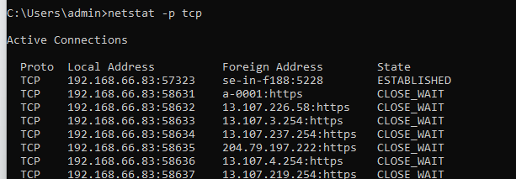

netstat -p udp:

  Displays only UDP connections.

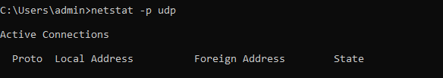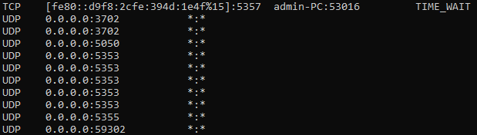

netstat -s:

Provides statistics for each protocol. This includes various network-related statistics such as TCP segments sent/received, UDP datagrams sent/received, etc.

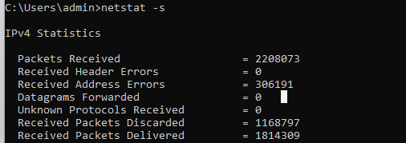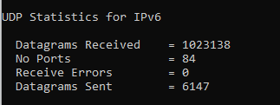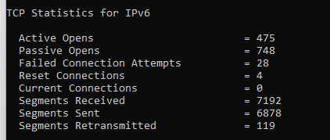

netstat -e:

Displays Ethernet statistics, including bytes sent/received, packets sent/received, and other network interface-specific information.

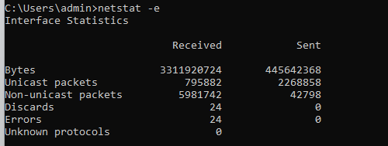

**ipconfig:**

Displays the IP configuration of all network interfaces, including IP addresses, subnet masks, default gateways, and DNS servers.

Example:-

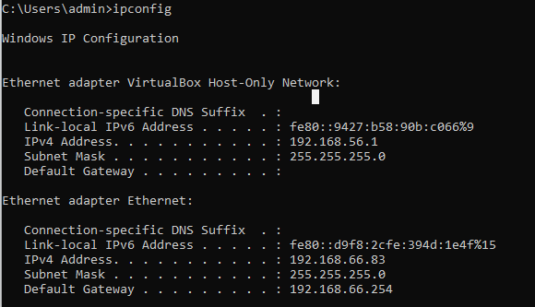

ipconfig /all:

Provides detailed information about the IP configuration of all network interfaces, including physical addresses (MAC addresses), DHCP lease information, and DNS settings.

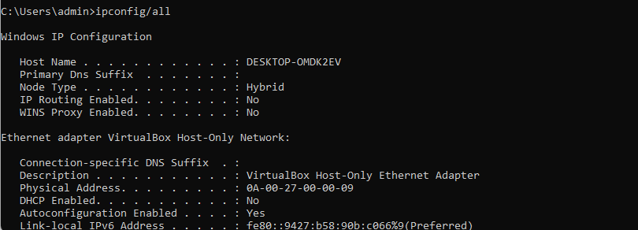

ipconfig /all:

Provides detailed information about the IP configuration of all network interfaces, including physical addresses (MAC addresses), DHCP lease information, and DNS settings.



ipconfig /?:

Displays the help information for the ipconfig command, providing details about the available flags and their usage.

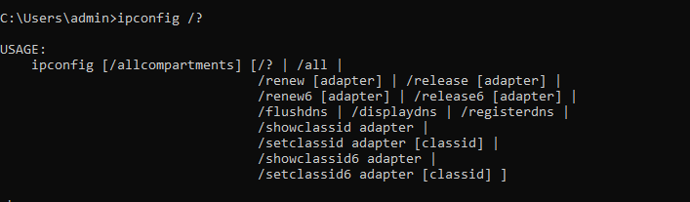

**nslookup:**

 It used for querying DNS (Domain Name System) to obtain domain-related information.

Example:

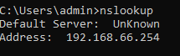

nslookup <domain>: Queries the DNS for the IP address of a specific domain.

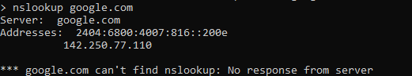

nslookup <IP address>: Performs a reverse DNS lookup to find the domain name associated with a given IP address.

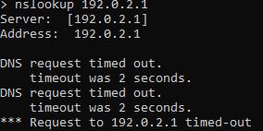

**ping:**

 command in Windows is used to test network connectivity and measure the response time between a source and destination. Here are some common ping commands with their flags and examples:

ping <hostname or IP address>: Sends ICMP echo requests to the specified destination and displays the round-trip time and status of each reply.

Example:

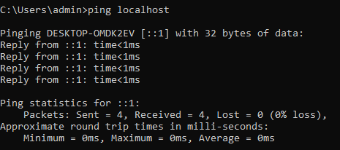

ping -t <hostname or IP address>:

Continuously pings the specified destination until manually stopped by pressing Ctrl+C.

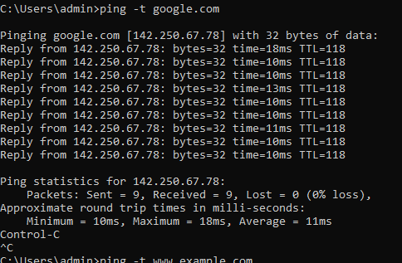

ping -n <count> <hostname or IP address>: Sends the specified number of ICMP echo requests to the destination.

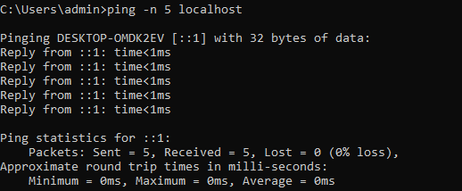

ping -6 <hostname or IP address>: Forces the use of IPv6 for the ping request.

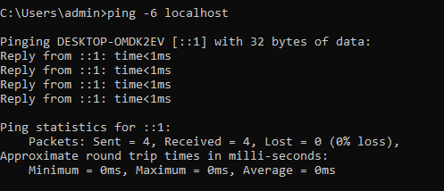

**RESULT**

Thus the various networks commands like tcpdump, netstat, ifconfig, nslookupand traceroute ping are executed successfully

|  |  |
| --- | --- |
| **EX.No: 2** | **Write a HTTP web client program to download a web page using TCP sockets** |
| **Date:** |

**AIM :**

To write a java program for socket for HTTP for web page upload and download .

**ALGORITHM:**

Client:

Step1:Start.

Step2:Create socket and establish the connection with the server. Step3:Read the image to be uploaded from the disk

Step4:Send the image read to the server Step5: Terminate the connection

Step6: Stop.

Server:

Step1:Start

Step2:Create socket, bind IP address and port number with the created socket and make server a listening server.

Step3:Accept the connection request from the client Step4:Receive the image sent by the client.

Step5:Display the image. Step6:Close the connection. Step7:Stop

**PROGRAM:**

Client:

import java.io.*;

import java.net.HttpURLConnection;

import java.net.URL;

import java.nio.file.Files;

import java.nio.file.Path;

import java.nio.file.StandardOpenOption;

public class SS {

private static final String SERVER_URL = "http://localhost:3001/image";

public static void main(String[] args) {

try {

URL url = new URL(SERVER_URL);

HttpURLConnection connection = (HttpURLConnection) url.openConnection();

connection.setRequestMethod("GET");

int responseCode = connection.getResponseCode();

if (responseCode == HttpURLConnection.HTTP_OK) {

String contentType = connection.getContentType();

if (contentType != null && contentType.startsWith("image/")) {

int contentLength = connection.getContentLength();

// Read the image data

InputStream inputStream = connection.getInputStream();

ByteArrayOutputStream imageData = new ByteArrayOutputStream();

byte[] buffer = new byte[1024];

int bytesRead;

while ((bytesRead = inputStream.read(buffer)) != -1) {

imageData.write(buffer, 0, bytesRead);

}

Path filePath = Path.of("./image.jpg");

Files.write(filePath, imageData.toByteArray(), StandardOpenOption.CREATE,

StandardOpenOption.TRUNCATE_EXISTING);

System.out.println("Image downloaded and saved to: " + filePath.toAbsolutePath());

} else {

System.out.println("The requested URL is not an image.");

}

} else {

System.out.println("Failed to download image. Response code: " + responseCode);

}

connection.disconnect();

} catch (IOException e) {

e.printStackTrace();

}

SERVER:

import java.io.*;

import java.net.ServerSocket;

import java.net.Socket;

import java.nio.file.Files;

import java.nio.file.Path;

import java.nio.file.StandardCopyOption;

public class Ser {

private static final int PORT = 3001;

private static final String IMAGE_PATH = "Java.jpg";

public static void main(String[] args) {

try (ServerSocket serverSocket = new ServerSocket(PORT)) {

System.out.println("Server listening on port " + PORT);

while (true) {

Socket clientSocket = serverSocket.accept();

System.out.println("Client connected: " + clientSocket.getInetAddress().getHostAddress());

BufferedReader request = new BufferedReader(new InputStreamReader(clientSocket.getInputStream()));

OutputStream response = clientSocket.getOutputStream();

String line = request.readLine();

if (line != null) {

String[] requestParts = line.split(" ");

if (requestParts.length >= 3 && requestParts[0].equals("GET")) {

String path = requestParts[1];

if (path.equals("/image")) {

serveImage(response);

} else {

serve404NotFound(response);

}

}

}

clientSocket.close();

System.out.println("Client disconnected");

}

} catch (IOException e) {

e.printStackTrace();

}

}

private static void serveImage(OutputStream response) throws IOException {

File imageFile = new File(IMAGE_PATH);

if (imageFile.exists()) {

byte[] imageBytes = Files.readAllBytes(Path.of(IMAGE_PATH));

PrintWriter pw = new PrintWriter(response);

pw.println("HTTP/1.1 200 OK");

pw.println("Content-Type: image/jpeg");

pw.println("Content-Length: " + imageBytes.length);

pw.println();

pw.flush();

response.write(imageBytes);

response.flush();

} else {

serve404NotFound(response);

}

}

private static void serve404NotFound(OutputStream response) throws IOException {

PrintWriter pw = new PrintWriter(response);

pw.println("HTTP/1.1 404 Not Found");

pw.println("Content-Type: text/html");

pw.println();

pw.println("<h1>404 Not Found</h1>");

pw.flush();

}

}

**Output:-**

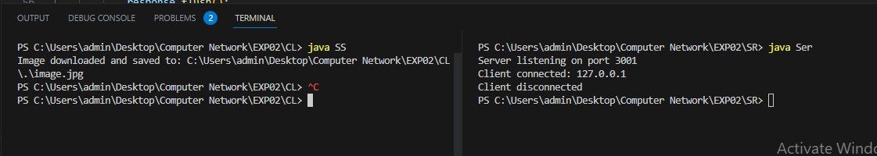

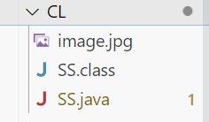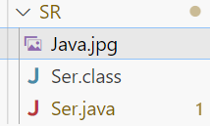

**RESULT:**

Thus the socket program for HTTP for web page upload and download was developed and executed successfully

|  |  |
| --- | --- |
| **Ex No: 3a** | **Applications using TCP sockets: Echo client and echo server** |
| **Date:** |

**AIM :**

To write a java program for application using TCP Sockets Link.

**ALGORITHM:**

Echo Client and Server Client:

Step1: Start

Step2: Create the TCP socket Step3:Establish connection with the server

Step4: Get the message to be echoed from the user Step5: Send the message to the server

Step6: Receive the message echoed by the server Step7: Display the message received from the server Step8: Terminate the connection

Step9: Stop

Server:

Step1: Start

Step2: Create TCP socket, make it a listening socket

Step3: Accept the connection request sent by the client for connection establishment Step4: Receive the message sent by the client

Step5: Display the received message

Step6: Send the received message to the client from which it receives

Step7: Close the connection when client initiates termination and server becomes a listening server, waiting for clients.

Step8: Stop.

**PROGRAM:**

EClient.java

package CL;

import java.net.*;

import java.io.*;

public class client {

public static void main(String arg[]) {

Socket c = null;

String line;

DataInputStream is, is1;

PrintStream os;

try {

InetAddress ia = InetAddress.getLocalHost();

c = new Socket(ia, 9000);

} catch (IOException e) {

System.out.println(e);

}

try {

os = new PrintStream(c.getOutputStream());

is = new DataInputStream(System.in);

is1 = new DataInputStream(c.getInputStream());

while (true) {

System.out.print("Client:");

line = is.readLine();

os.println(line);

System.out.println("Server: " + is1.readLine());

}

} catch (IOException e) {

System.out.println("Socket Closed!");

}

}

}

EServer.java

package SR;

import java.net.*;

import java.io.*;

public class server {

public static void main(String args[]) {

ServerSocket s = null;

String line;

DataInputStream is = null;

PrintStream ps = null;

Socket c = null;

try {

s = new ServerSocket(9000);

c = s.accept();

is = new DataInputStream(c.getInputStream());

ps = new PrintStream(c.getOutputStream());

while (true) {

line = is.readLine();

if (line == null) {

break;

}

ps.println(line);

}

} catch (IOException e) {

System.out.println("Error: " + e.getMessage());

} finally {

try {

if (is != null) is.close();

if (ps != null) ps.close();

if (c != null) c.close();

if (s != null) s.close();

} catch (IOException ex) {

System.out.println("Error while closing resources: " + ex.getMessage());

}

}

}

}

**Output:-**

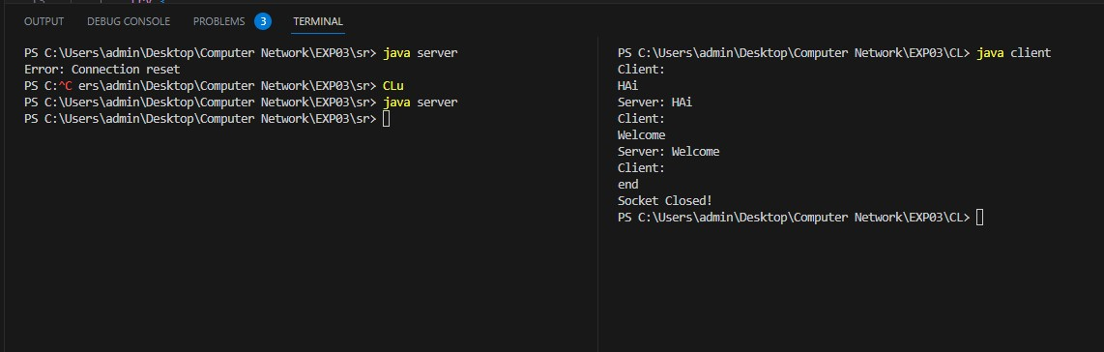

**RESULT:**

Thus the java application program using TCP Sockets was developed and executed successfully

|  |  |
| --- | --- |
| **Ex No: 3b** | **Applications using TCP sockets: Chat** |
| **Date:** |

**AIM:**

To write a java program for application using TCP Sockets Link for ChatApplication.

**ALGORITHM:**

Client:

Step1: Start

Step2: Create the UDP datagram socket

Step3: Get the request message to be sent from the user Send the request message to the server

Step4: If the request message is ―END‖ go to step 10 Step5: Wait for the reply message from the server Step6: Receive the reply message sent by the server

Step8: Display the reply message received from the server Step9: Repeat the steps from 3 to 8

Step10: Stop

Server:

Step1: Start

Step2: Create UDP datagram socket, make it a listening socket Step3: Receive the request message sent by the client

Step4: If the received message is ―END‖ go to step 10

Step5: Retrieve the client‘s IP address from the request message received Step6: Display the received message

Step7: Get the reply message from the user

Step8: Send the reply message to the client

**PROGRAM:**

UDPserver.java

import java.io.*;

import java.net.*;

public class server {

private static int indexOf(String[] array, String str) {

str = str.trim();

for (int i = 0; i < array.length; i++) {

if (array[i].equals(str))

return i;

}

return -1;

}

public static void main(String arg[]) {

String[] hosts = { "yahoo.com", "gmail.com", "cricinfo.com", "facebook.com" };

String[] ip = { "68.180.206.184", "209.85.148.19", "80.168.92.140", "69.63.189.16" };

System.out.println("Press Ctrl + C to Quit");

while (true) {

try {

DatagramSocket serversocket = new DatagramSocket(1362);

byte[] receivedata = new byte[1021];

DatagramPacket recvpack = new DatagramPacket(receivedata, receivedata.length);

serversocket.receive(recvpack);

String sen = new String(recvpack.getData()).trim();

InetAddress ipaddress = recvpack.getAddress();

int port = recvpack.getPort();

String capsent;

System.out.println("Request for host " + sen);

int index = indexOf(hosts, sen);

if (index != -1) {

capsent = ip[index];

} else {

capsent = "Host Not Found";

}

byte[] senddata = capsent.getBytes();

DatagramPacket pack = new DatagramPacket(senddata, senddata.length, ipaddress, port);

serversocket.send(pack);

serversocket.close();

} catch (IOException e) {

System.out.println("Error: " + e.getMessage());

}

}

}

}

UDPClient.java

import java.io.*;

import java.net.*;

public class cl {

public static void main(String args[]) {

try {

BufferedReader br = new BufferedReader(new InputStreamReader(System.in));

DatagramSocket clientsocket = new DatagramSocket();

InetAddress ipaddress;

if (args.length == 0)

ipaddress = InetAddress.getLocalHost();

else

ipaddress = InetAddress.getByName(args[0]);

byte[] senddata = new byte[1024];

byte[] receivedata = new byte[1024];

int portaddr = 1362;

System.out.print("Enter the hostname: ");

String sentence = br.readLine();

senddata = sentence.getBytes();

DatagramPacket pack = new DatagramPacket(senddata, senddata.length, ipaddress, portaddr);

clientsocket.send(pack);

DatagramPacket recvpack = new DatagramPacket(receivedata, receivedata.length);

clientsocket.receive(recvpack);

String modified = new String(recvpack.getData()).trim();

System.out.println("IP Address: " + modified);

clientsocket.close();

} catch (IOException e) {

System.out.println("Error: " + e.getMessage());

}

}

}

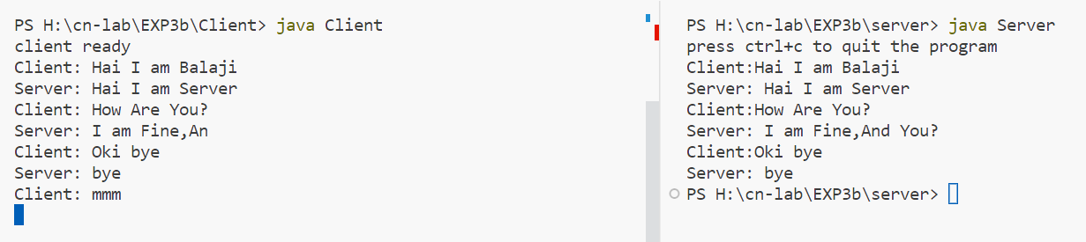**Output:-**

**RESULT:**

Thus the java application program using TCP Sockets was developed and executed successfully.

|  |  |
| --- | --- |
| **Ex No: 3c** | **Applications using TCP sockets: File Transfer** |
| **Date:** |

**AIM:**

To write a java program for file transfer using TCP Sockets.

**ALGORITHM:**

Server:

Step 1:Import java packages and create class file server.

Step 2:Create a new server socket and bind it to the port.

Step 3:Accept the client connection

Step 4:Get the file name and stored into the BufferedReader.

Step 5:Create a new object class file and realine.

Step 6:If file is exists then FileReader read the content until EOF is reached.

Step 7:Stop the program.

Client:

Step 1:Import java packages and create class file server.

Step 2:Create a new server socket and bind it to the port.

Step 3:Now connection is established.

Step 4:The object of a BufferReader class is used for storing data content which has beenretrieved from socket object.

Step 5:The connection is closed.

Step 6:Stop the program.

**PROGRAM:**

File Server :

import java.io.*;

import java.net.*;

public class Server {

public static void main(String[] args) throws Exception {

// Initialize ServerSocket

ServerSocket ssock = new ServerSocket(5000);

Socket socket = ssock.accept();

// Specify the file

File file = new File("index.html");

FileInputStream fis = new FileInputStream(file);

BufferedInputStream bis = new BufferedInputStream(fis);

OutputStream os = socket.getOutputStream();

byte[] contents;

long fileLength = file.length();

long current = 0;

while (current != fileLength) {

int size = 10000;

if (fileLength - current >= size)

current += size;

else {

size = (int) (fileLength - current);

current = fileLength;

}

contents = new byte[size];

bis.read(contents, 0, size);

os.write(contents);

System.out.print("Sending file... " + (current * 100) / fileLength + "% complete!\n");

}

os.flush();

socket.close();

ssock.close();

System.out.println("File sent successfully!");

}

}

File Client:

import java.io.*;

import java.net.*;

public class Client {

public static void main(String[] args) throws Exception {

// Initialize socket

Socket socket = new Socket(InetAddress.getByName("localhost"), 5000);

byte[] contents = new byte[10000];

int bytesRead;

InputStream is = socket.getInputStream();

FileOutputStream fos = new FileOutputStream("receivedFile.html");

BufferedOutputStream bos = new BufferedOutputStream(fos);

while ((bytesRead = is.read(contents)) != -1) {

bos.write(contents, 0, bytesRead);

}

bos.flush();

socket.close();

System.out.println("File saved successfully!");

}

}

**Output:-**

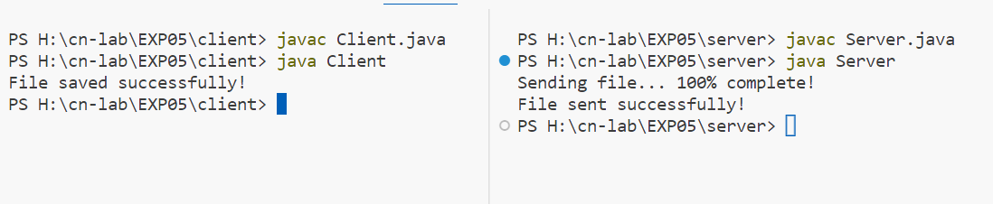

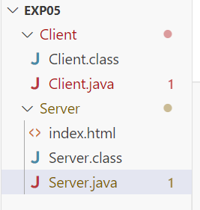 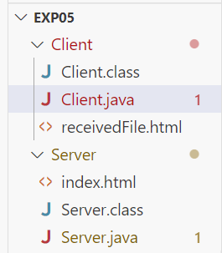

**RESULT:**

Thus the java application program using TCP Sockets was developed and executed successfully

|  |  |
| --- | --- |
| **Ex No: 4** | **Simulation of DNS using UDP sockets.** |
| **Date:** |

**AIM:**

To write a java program for file transfer using TCP Sockets.

**ALGORITHM:**

Server:-

1.Start

2.Create UDP datagram socket

3.Create a table that maps host name and IP address

4.Receive the host name from the client

5.Retrieve the client‘s IP address from the received datagram

6.Get the IP address mapped for the host name from the table.

7.Display the host name and corresponding IP address

8.Send the IP address for the requested host name to the client

9.Stop.

Client:-

1.Start

2.Create UDP datagram socket.

3.Get the host name from the client

4.Send the host name to the server

5.Wait for the reply from the server

6.Receive the reply datagram and read the IP address for the requested host name

7.Display the IP address.

8.Stop.

**PROGRAM:**

Client

import java.io.*;

import java.net.*;

public class cl {

public static void main(String args[]) {

try {

BufferedReader br = new BufferedReader(new InputStreamReader(System.in));

DatagramSocket clientsocket = new DatagramSocket();

InetAddress ipaddress;

if (args.length == 0)

ipaddress = InetAddress.getLocalHost();

else

ipaddress = InetAddress.getByName(args[0]);

byte[] senddata = new byte[1024];

byte[] receivedata = new byte[1024];

int portaddr = 1362;

System.out.print("Enter the hostname: ");

String sentence = br.readLine();

senddata = sentence.getBytes();

DatagramPacket pack = new DatagramPacket(senddata, senddata.length, ipaddress, portaddr);

clientsocket.send(pack);

DatagramPacket recvpack = new DatagramPacket(receivedata, receivedata.length);

clientsocket.receive(recvpack);

String modified = new String(recvpack.getData()).trim();

System.out.println("IP Address: " + modified);

clientsocket.close();

} catch (IOException e) {

System.out.println("Error: " + e.getMessage());

}

}

}

Server

import java.io.*;

import java.net.*;

public class server {

private static int indexOf(String[] array, String str) {

str = str.trim();

for (int i = 0; i < array.length; i++) {

if (array[i].equals(str))

return i;

}

return -1;

}

public static void main(String arg[]) {

String[] hosts = { "yahoo.com", "gmail.com", "cricinfo.com", "facebook.com" };

String[] ip = { "68.180.206.184", "209.85.148.19", "80.168.92.140", "69.63.189.16" };

System.out.println("Press Ctrl + C to Quit");

while (true) {

try {

DatagramSocket serversocket = new DatagramSocket(1362);

byte[] receivedata = new byte[1021];

DatagramPacket recvpack = new DatagramPacket(receivedata, receivedata.length);

serversocket.receive(recvpack);

String sen = new String(recvpack.getData()).trim();

InetAddress ipaddress = recvpack.getAddress();

int port = recvpack.getPort();

String capsent;

System.out.println("Request for host " + sen);

int index = indexOf(hosts, sen);

if (index != -1) {

capsent = ip[index];

} else {

capsent = "Host Not Found";

}

byte[] senddata = capsent.getBytes();

DatagramPacket pack = new DatagramPacket(senddata, senddata.length, ipaddress, port);

serversocket.send(pack);

serversocket.close();

} catch (IOException e) {

System.out.println("Error: " + e.getMessage());

}

}

}

}

**Output:-**

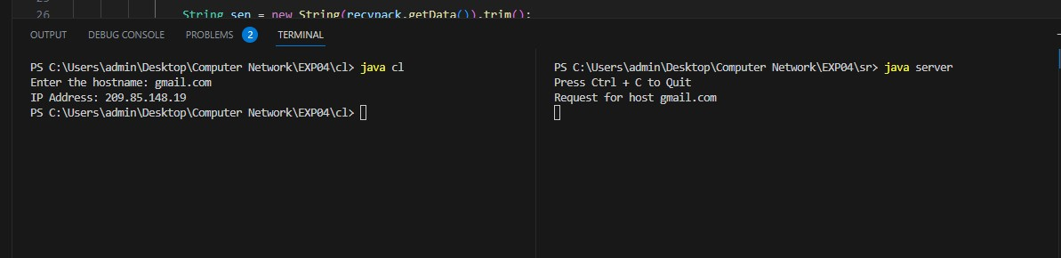

**RESULT:**

Thus the java application program using UDP Sockets to implement DNS was

developed and executed successfully.